71.00.00
From Louisa Calvert
RB MSS M1, Library, Royal Botanic Gardens Melbourne.

Dear Dr. Von Mueller
During the 3rd week of May I forwarded a parcel of specimens to Dr Woolls which I hope have long since reached you — They were chiefly Ruses, Reeds and grasses — The enclosed seeds are Oaks No 1, from the dry sandy ranges above Queenbeyan towards Manero No 2 from the mountain Brook which takes its source in the lower spurs of the Alps — a cold locality. The oaks there exceed any swamp oaks I have seen elsewhere in hieght & girth — say 100 to 150 high and 12 feet circumference. They are luxuriant trees with the habit of growth of the Pines of Norway.
No.1 is a tree about 20 feet high and 1 foot in diameter with drooping long foliage giving a soft round appearance to the tree — I send a rough outline of the general appearance of the trees — The seed vessels of this one are very large, I sent specimens in the parcel of plants forwarded in May. The wing when moistened becomes viscid and floats in water like threads but not further soluble — it has a slight resinous tast — I had a number of young trees but the mice gnaw them whereever planted and destroy them — I am surprised to hear from Dr. Woolls that he is only acquainted with 3 species of Casuarina I know of 6 if not seven and will endeavour to forward you specimens of all — No 3 is the seed of our common Forest oak — a round topped dull green tree found on ranges not so ornimental as No 1. The sketch of seed vessels may enable you to deturmine the species. The thread like foliage of No 1 is fully twice as thick as that of No 3 and twice as large — color a soft yellow green — Even from a distance a distinct tree — Did Mr. Woolls ever send you the cone of a Pine from Mt. Tomah? I only had the one I gave him.
My husband desires his kindest regards — he has received the 3 Goats safe and well and is much pleased with them.
Dear Dr. von Mueller with best wishes
Yours gratefully
Louisa Calvert

Casuarina
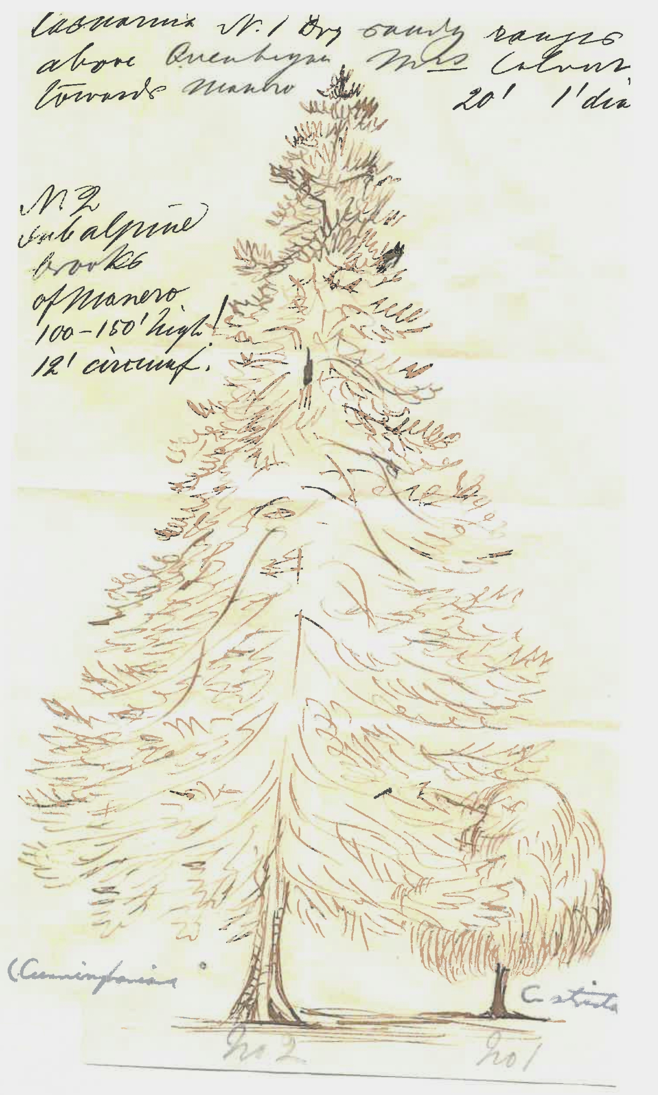

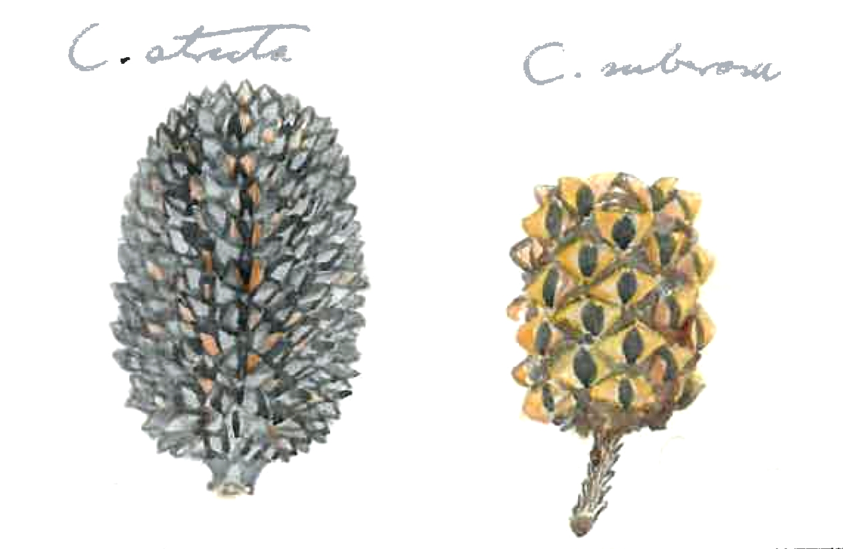

Formerly Louisa Atkinson. MS found with a sheet of Casuarina cunninghamiana (MEL 0538121C) to which are attached three packets of seed as well as two drawings. 71-00-00_image01.jpg and 71-00-00_image02.jpg The drawing of the two trees has been annotated in ink by M, and in a different hand names have been added in pencil to the drawings of both the trees and the seed vessels. M's annotations are: above image: Casuarina N. 1 Dry sandy ranges above Quenbeyan towards Manero. Mrs Calvert 20' 1' dia to left of image: N. 2 subalpine brooks of Manero 100-150' high! 12' circumf. The letter is dated by its relationship to M to L. Calvert, 31 January 1871; see below.
Rushes?
Queanbeyan, NSW.
Louisa Calvert's husband James Calvert had been seeking some Angora goats for breeding purposes; see M to L. Calvert, 31 January 1871.

